**Requirements for Front Accounting**

1. **New Sales Quotation Entry: Field description**

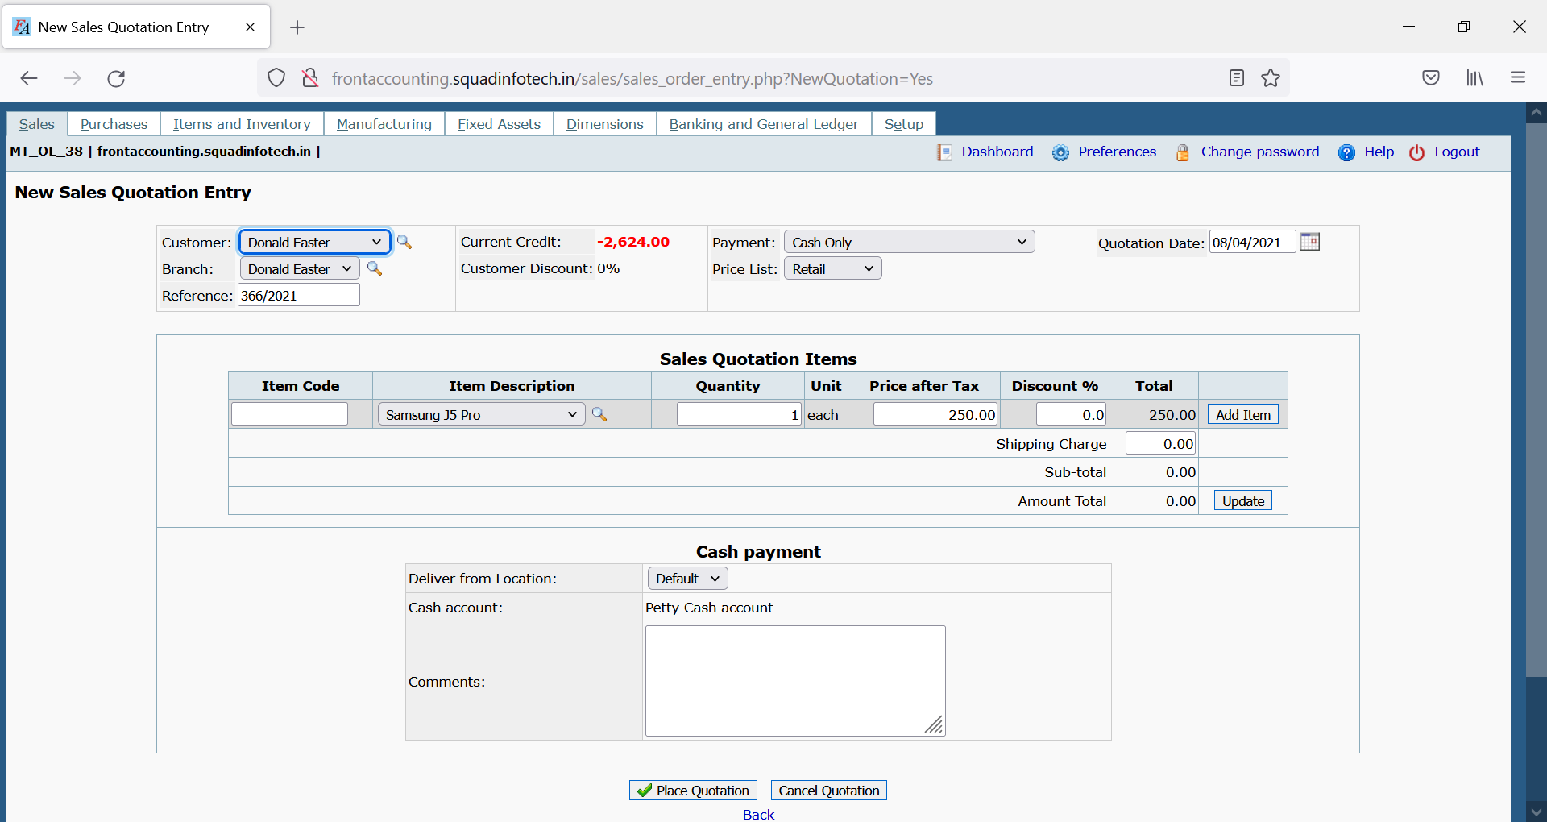

|  |  |
| --- | --- |
| Field Name | Description |
| Customer | This is Drop down object which displays data of existing customers who are registered in our database. |
| Branch | This field represents customer’s business location which we have registered in our database while registering the customer. One customer may have multiple locations as Branch from where customer might be operating the business. |
| Reference | This is auto-generated field. |
| Current Credit | This is the credit limit offered to the customer. |
| Customer Discount | For premium customers this can be default discount on all orders/quotations. This would be 0 by default for all new customer. |
| Payment | This drop down field should select the payment terms with the customer. Payment terms are as following:   1. Cash Only 2. Due 15th of the following month 3. Due by end of the following month 4. Payment due within 10 days |
| Price List | This field decides the price action based on the quantity of purchase. This field has following values”   1. Retail 2. Wholesale |
| Quotation Date | Default value is system date when the Quotation Entry was done. This field may permit past date but should not permit future date. |
| Item Code | This field should allow the user to directly type the item code of the product for which the quotation is being made. One entering valid item code, the following fields should be filled:   1. Item Description 2. Quantity 3. Price after Tax / Price before Tax 4. Discount 5. Total (non-editable filed)   User can click “Add Item” to add the item in quotation and a new product row with blank data should be added. |
| Item Description | This is alternate way to add item in the quotation. Instead of adding item using Item Code, user can select the product from the drop down. Once the product is selected from Item Description following fields should be filled:   1. Item Code 2. Quantity 3. Price after Tax / Price before Tax 4. Discount 5. Total (non-editable filed)   User can click “Add Item” to add the item in quotation and a new product row with blank data should be added. |
| Quantity | Default value should be 1 quantity. |
| Price after Tax / Price before Tax | Should display the pre entered price form data base. |
| Discount | If the customer is offered discount, mention the percentage. |
| Total | Non-Editable field. This filed should display the total price of the product after applying discount (if applied). |
| Add Item Button | This button should add the item in the Quotation Entry. On successful entry of the product, Edit button (displayed as Pencil icon) and Delete button (displayed as Red X) should be displayed. |
| Shipping Charge | Add any shipping charge to be charged from customer here. |
| Sub Total | Sub-total is non-editable field. This should display the final total for all products, considering the quantity, price after tax, discount, and shipping charge. |
| Included Tax | Tax is charged at 5%. This is non-editable |
| Amount Total | This is Non editable field. This is the final cost for the customer. |
| Update Button | If there is change in the shipping charges this button will update the values in the form. |
| Deliver from Location | Drop lists different warehouses. User can select this order would be fulfilled from which warehouse. |
| Valid until | Select the date till when this quotation is considered valid. After this date, this quotation would be considered invalid and user should not be able to convert this quotation to sales order. |
| Deliver To | This field should display the customer branch location where are order is required to deliver. |
| Address | Address of the customer branch where the order is to be delivered. |
| Contact Phone Number | The contact number of the customer who would receive the order |
| Customer Reference | This is editable field. User can enter a unique customer identification number. |
| Comments | And additional comments required to be mentioned, can be entered here. |
| Shipping Company | Select the shipping company who would be delivering this order to the customer. |
| Place Quotation | This button should successfully add quotation entry in the ERP. |
| Cancel Quotation | It should cancel the quotation |

1. **Sales Order Entry: Field Description**

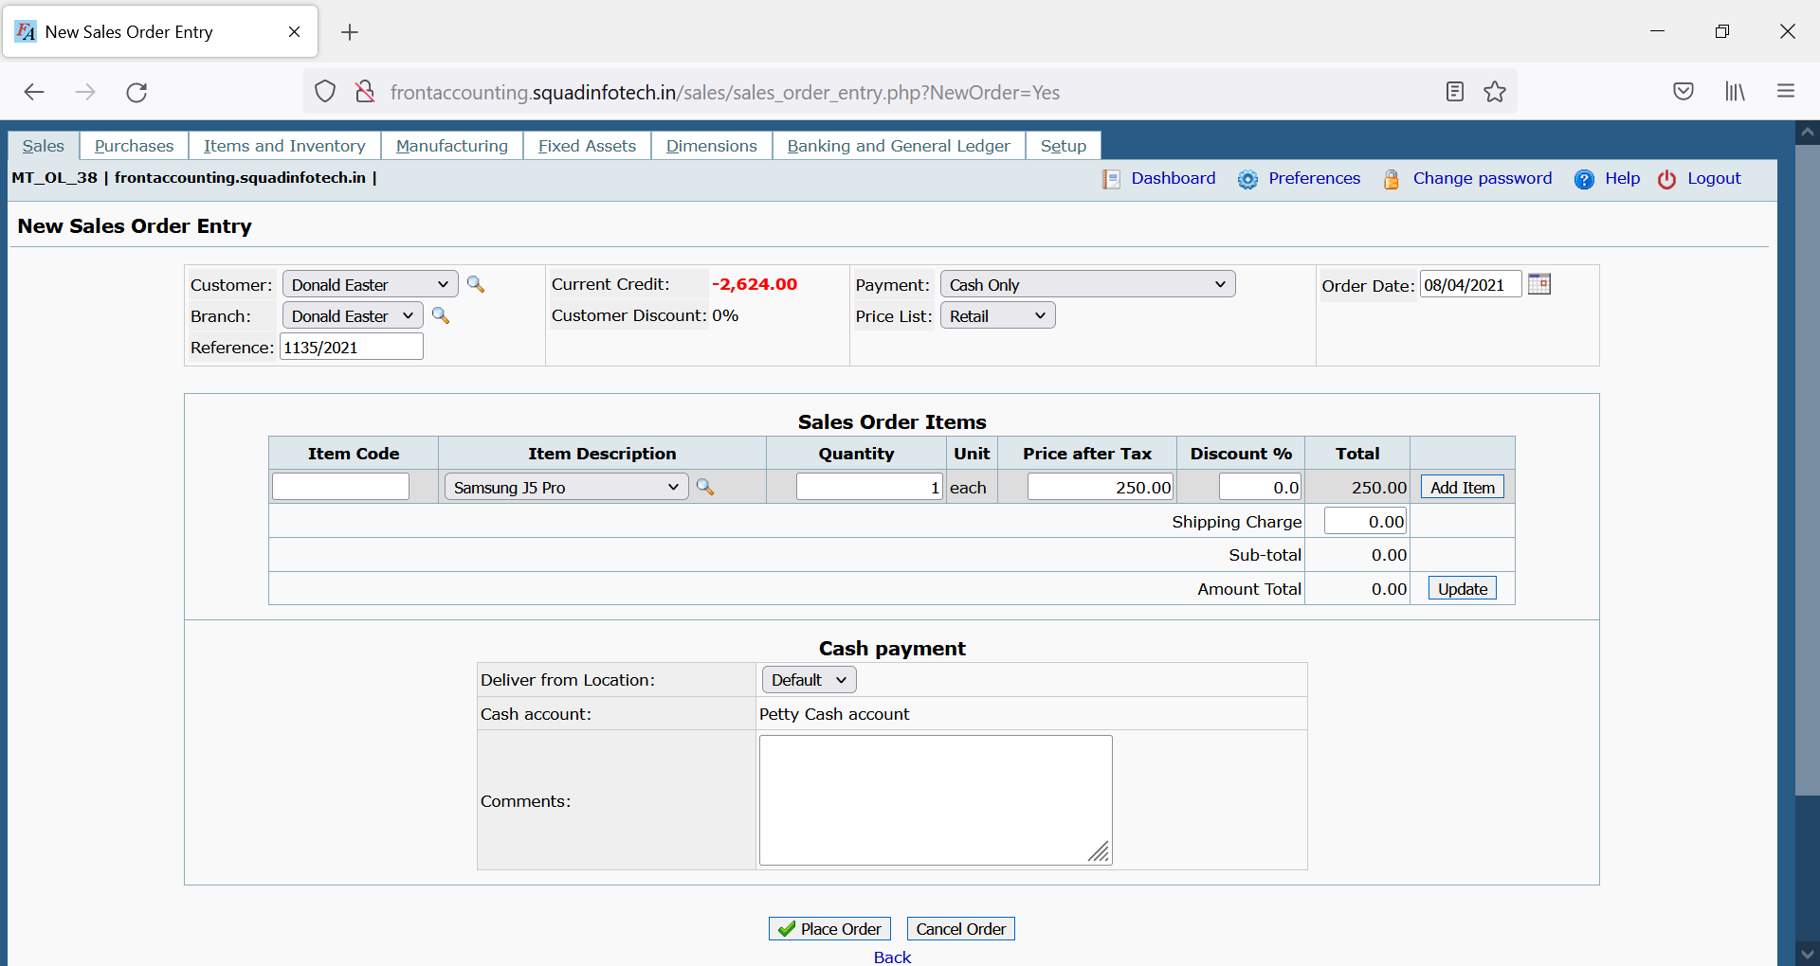

|  |  |
| --- | --- |
| Field Name | Description |
| Customer | This is Drop down object which displays data of existing customers who are registered in our database. |
| Branch | This field represents customer’s business location which we have registered in our database while registering the customer. One customer may have multiple locations as Branch from where customer might be operating the business. |
| Reference | This is auto-generated field. |
| Current Credit | This is the credit limit offered to the customer. |
| Customer Discount | For premium customers this can be default discount on all orders/quotations. This would be 0 by default for all new customer. |
| Payment | This drop down field should select the payment terms with the customer. Payment terms are as following:   1. Cash Only 2. Due 15th of the following month 3. Due by end of the following month 4. Payment due within 10 days |
| Price List | This field decides the price action based on the quantity of purchase. This field has following values”   1. Retail 2. Wholesale |
| Order Date | Default value is system date when the Order Entry was done. This field may permit past date but should not permit future date. |
| Item Code | This field should allow the user to directly type the item code of the product for which the Order is being made. One entering valid item code, the following fields should be filled:   1. Item Description 2. Quantity 3. Price after Tax / Price before Tax 4. Discount 5. Total (non-editable filed)   User can click “Add Item” to add the item in Order and a new product row with blank data should be added. |
| Item Description | This is alternate way to add item in the Order. Instead of adding item using Item Code, user can select the product from the drop down. Once the product is selected from Item Description following fields should be filled:   1. Item Code 2. Quantity 3. Price after Tax / Price before Tax 4. Discount 5. Total (non-editable filed)   User can click “Add Item” to add the item in Order and a new product row with blank data should be added. |
| Quantity | Default value should be 1 quantity. |
| Price after Tax / Price before Tax | Should display the pre entered price form data base. |
| Discount | If the customer is offered discount, mention the percentage. Discount percentage should not exceed 15% |
| Total | Non-Editable field. This filed should display the total price of the product after applying discount (if applied). |
| Add Item Button | This button should add the item in the Quotation Entry. On successful entry of the product, Edit button (displayed as Pencil icon) and Delete button (displayed as Red X) should be displayed. |
| Shipping Charge | Add any shipping charge to be charged from customer here. |
| Sub Total | Sub-total is non-editable field. This should display the final total for all products, considering the quantity, price after tax, discount, and shipping charge. |
| Included Tax | Tax is charged at 5%. This is non-editable |
| Amount Total | This is Non editable field. This is the final cost for the customer. |
| Update Button | If there is a change in the shipping charges, this button will update the values in the form. |
| Deliver from Location | Drop lists different warehouses. User can select this order would be fulfilled from which warehouse. |
| Required delivery date | Select the date till when this delivery is required. |
| Deliver To | This field should display the customer branch location where are order is required to deliver. |
| Address | Address of the customer branch where the order is to be delivered. |
| Contact Phone Number | The contact number of the customer who would receive the order |
| Customer Reference | This is editable field. User can enter a unique customer identification number. |
| Comments | And additional comments required to be mentioned, can be entered here. |
| Shipping Company | Select the shipping company who would be delivering this order to the customer. |
| Place Order | This button should successfully add Sales Order entry in the ERP. |
| Cancel Order | It should cancel the Order |

1. **Deliver Items for Sales Order: Field description**

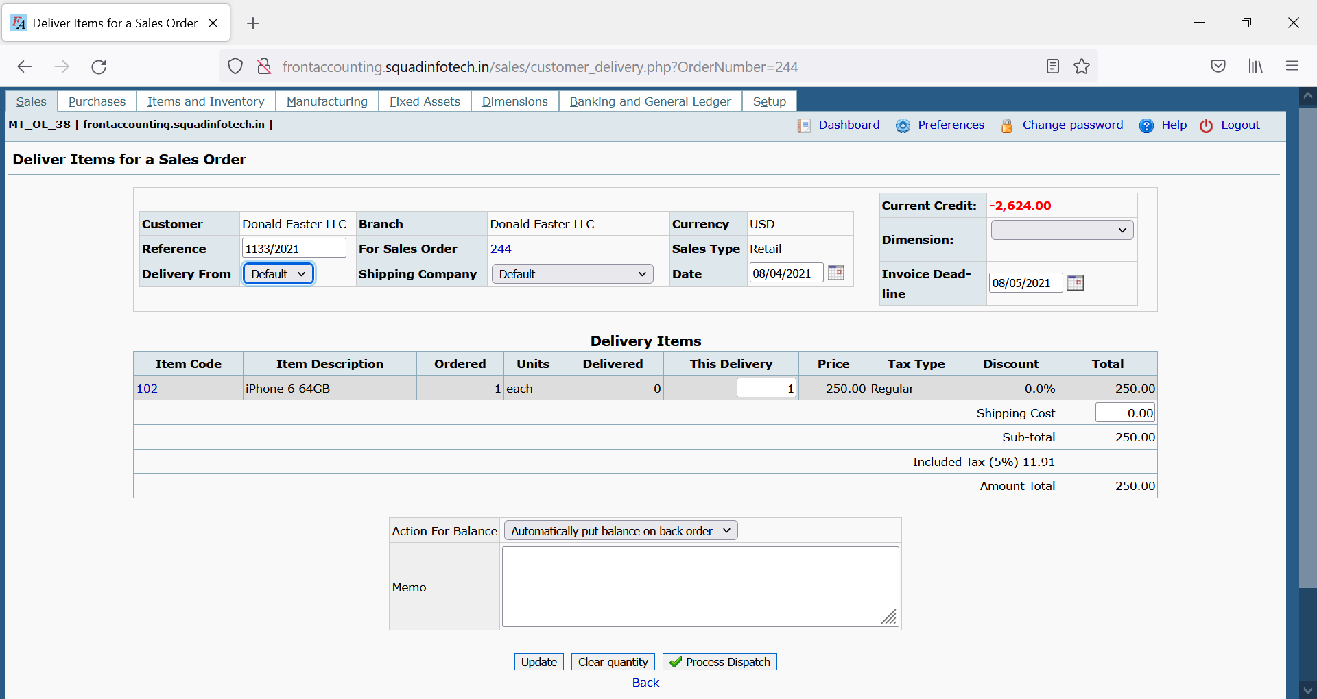

|  |  |
| --- | --- |
| Field Name | Description |
| Customer | This is non-editable field. This field displays the name of the customer for whom the sales order was created. |
| Reference | This is auto-generated field. |
| Delivery From | This field should display the warehouse which was selected while entering the quotation / sales order. |
| Branch | This field should display the branch which was selected while entering the quotation / sales order. |
| For Sales Order | This field should display the sales order number of the selected order. |
| Shipping Company | This field should display the branch which was selected while entering the quotation / sales order. This is drop down and shipping company can be changed if required. |
| Currency | This field displays the currency in which the customer will be making the payment. This is pre-defined currency while registering the new customer. |
| Sales Type | This field displays the type of sales as below:   1. Retail 2. Wholesale   This is display field displaying the price list which was selected while entering the Quotation / Sales Order. |
| Date | Default value is system date when the Delivery Entry was done. This field may permit past date but should not permit future date. |
| Current Credit | This is the credit limit offered to the customer. |
| Dimension | Feature not to be tested |
| Invoice Dead-line | This is deadline by when the invoice has to be created. This should permit future date but before the payment date as selected while creating the sales order. |
| Item Code | This is non editable field. This field should display the item codes of all products for which the Sales Order was created. |
| Item Description | This is non editable field. This field should display the product names for relevant item codes for which the Sales Order was created. |
| Ordered | This is non-editable field. This should display the quantity of each product, as mentioned while creating the sales order. |
| Delivered | This is non-editable field. This field should display the quantity that has been dispatched and delivered to the customer. While creating the delivery for first time for newly created sales order, this field should display “0”. For partial quantity delivered, this field should mention the quantity delivered against the sales order till date. |
| This Delivery | Enter the quantity of the respective item which is being dispatched. This value can be less than or equal to Ordered quantity but cannot be more than ordered quantity. |
| Price | Should display the per quantity price of the product. |
| Tax Type | This is non-editable field. This should display the tax payment information of the customer. This is mentioned while registering new customer in ERP. |
| Discount | This field displays the discount which was mention while entering the sales order. |
| Total | Non-Editable field. This filed should display the total price of the product after applying discount (if applied). |
| Shipping Charge | Add any shipping charge to be charged from customer here. |
| Sub Total | Sub-total is non-editable field. This should display the final total for all products, considering the quantity, price after tax, discount, and shipping charge. |
| Included Tax | Tax is charged at 5%. This is non-editable |
| Amount Total | This is Non editable field. This is the final cost for the customer. |
| Action for Balance | Which dropdown decides the further action of pending quantity in case partial quantity is dispatched. This dropdown has following options:   1. Automatically put balance on back order:   **On successful “Process Dispatch”, if “This Delivery” quantity is less than the “Ordered” quantity, then the quantity mentioned in “This Delivery” should be displayed as “Delivered” quantity.**   1. Cancel any quantities not delivered.   **On successful “Process Dispatch” if “This Delivery” quantity was less than “Ordered” Quantity, then “Ordered” quantity should be replaced with “This Delivery” quantity.** |
| Memo | This field should display the information mentioned in Comments field while entering the sales order. |
| Update | If there is any change in “This Delivery” quantity or “Shipping Cost” this button will update the values in the form. |
| Clear Quantity | This field should reset the “This Delivery” quantity to default value as 1. |
| Process Dispatch | This button should make a successful dispatch entry for the warehouse. |

1. **Issue Invoice for Delivery Note: Field Description**

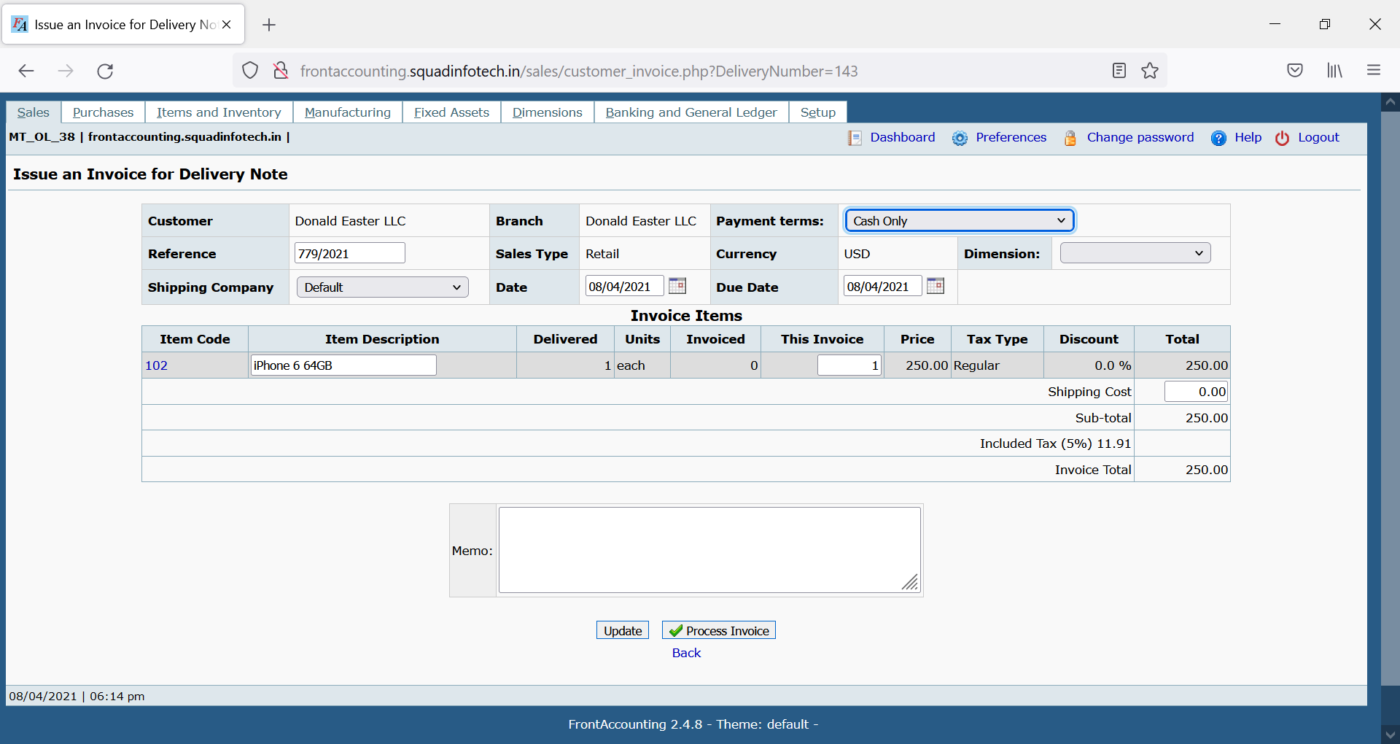

|  |  |
| --- | --- |
| Field Name | Description |
| Customer | This is Drop down object which displays data of existing customers who are registered in our database. |
| Reference | This is auto-generated field. |
| Shipping Company | Select the shipping company who would be delivering this order to the customer. |
| Branch | This field represents customer’s business location which we have registered in our database while registering the customer. One customer may have multiple locations as Branch from where customer might be operating the business. |
| Sales Type | This field displays the type of sales as below:   1. Retail 2. Wholesale   This is display field displaying the price list which was selected while entering the Quotation / Sales Order. |
| Date | Default value is system date when the Delivery Entry was done. This field may permit past date but should not permit future date. |
| Payment | This drop down field should select the payment terms with the customer. Payment terms are as following:   1. Cash Only 2. Due 15th of the following month 3. Due by end of the following month 4. Payment due within 10 days |
| Currency | This field displays the currency in which the customer will be making the payment. This is pre-defined currency while registering the new customer. |
| Due Date | Select the date after which the invoice amount mentioned would be considered invalid. This is to be selected based on the payment terms selected. **Ex. If the invoice date is 10th Oct 2020 and Payment terms “Payment due within 10 days” is selected, then the due date should be 20th Oct 2020.** |
| Dimension | Feature not to be tested |
| Item Code | This is non editable field. This field should display the item codes of all products for which the Sales Order was created. |
| Item Description | This is non editable field. This field should display the product names for relevant item codes for which the Sales Order was created. |
| Delivered | This is non-editable field. This field should display the quantity that has been processed, dispatched and delivered to the customer. **The details should be fetched from the Delivery Note which was processed and dispatched**. |
| Invoiced | This is non-editable field. This field should display the quantity that has been invoiced. **While creating the invoice for first time for newly created delivery note, this field should display “0”. For partial quantity delivered, this field should mention the quantity that has been invoiced till date.** |
| This Invoice | Enter the quantity of the respective item which is to be invoiced. **This value can be less than or equal to Delivered quantity but cannot be more than “Delivered” minus “Invoiced” quantity.** |
| Price | Should display the per quantity price of the product. |
| Tax Type | This is non-editable field. This should display the tax payment information of the customer. This is mentioned while registering new customer in ERP. |
| Discount | If the customer is offered discount, mention the percentage. Discount percentage should not exceed 15% |
| Total | Non-Editable field. This filed should display the total price of the product after applying discount (if applied). |
| Shipping Charge | Add any shipping charge to be charged from customer here. |
| Sub Total | Sub-total is non-editable field. This should display the final total for all products, considering the quantity, price after tax, discount, and shipping charge. |
| Included Tax | Tax is charged at 5%. This is non-editable |
| Amount Total | This is Non editable field. This is the final cost for the customer. |
| Memo | This field should display the information mentioned in Comments field while entering the sales order. |
| Update | If there is any change in “This Invoice” quantity or “Shipping Cost” this button will update the values in the form. |
| Process Invoice | This button should make a successful dispatch entry for the warehouse. |

1. **Customer Payment Entry: Field Description**

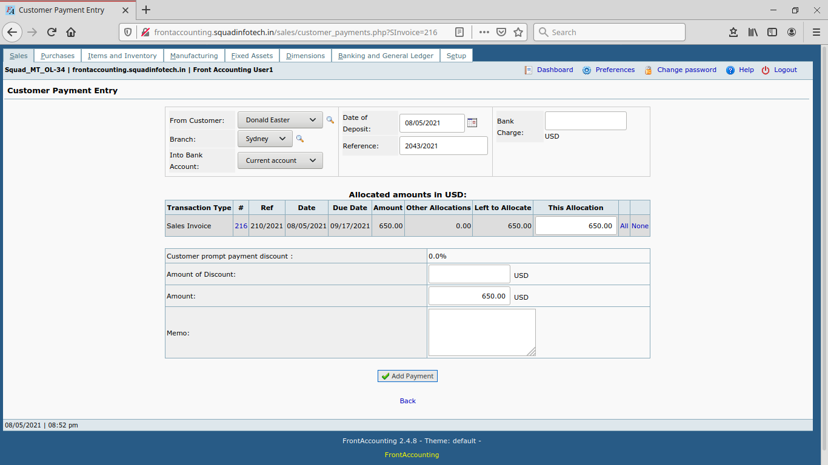

|  |  |
| --- | --- |
| Field Name | Description |
| Into Bank Account | Type of accounts in which the amount should be deposited. It includes the option like current account & petty cash account. |
| From Customer | This field displays the name of the customer for whom the sales order was created. |
| Branch | This field represents customer’s business branch location which was selected while creating the sales order. |
| Date of Deposit | Default value is system date, Date of transaction when then payment was deposited. |
| Reference | This is auto-generated field. |
| Bank Charge | Any charges bank levied on the transaction need to be mentioned here. |
| Transaction Type | This is non editable field. This field must display the type of transaction against which the payment was made. |
| # | The number below the # indicates the invoice number for which the payment is being entered. |
| Ref | Non editable. Must display the reference which was auto-generated while entering the quotation. |
| Date | Date when invoice was made. |
| Due Date | Last Date of payment to be made. |
| Amount | Amount as per invoice which was raised. |
| Other Allocations | The amount which was already paid. |
| Left to Allocate | Amount yet to be billed. |
| This Allocation | Amount to be billed in current invoice. |
| All | This link will take all the amount as per invoice which was raised. |
| None | This link should reset the “This Allocation” amount. |
| Customer Prompt Payment Discount | This Should be auto-generated based on the amount of discount |
| Amount of Discount | Here mention the amount in this field promptly offer to the customer. (Additionally offered to the customer) |
| Amount | This field should display the final amount after deduction of the discount amount. |
| Memo | Mention any additional comment about the payment. |
| Add Payment | This button should make a successful Payment Entry to the customer. |

1. **Purchase Order Entry: Field Description**

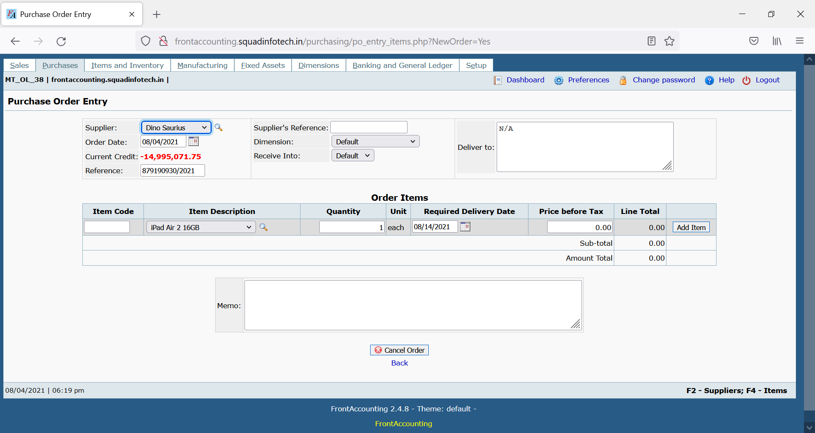

|  |  |
| --- | --- |
| Field Name | Description |
| Supplier | This is Drop down object which displays data of existing suppliers who are registered in our database |
| Order Date | The date when the order was placed to the supplier for purchasing the items. |
| Current Credit | The amount which is yet to be paid to the supplier by us. |
| Reference | This is auto-generated field. This is editable field and we can enter customised reference number if needed. |
| Supplier’s Reference | This is supplier’s reference number allotted by us. |
| Dimension | Feature not to be tested |
| Receive Into | This use need to select the warehouse in which the ordered items are to be received. |
| Deliver To | The user must enter name of the receiver in the warehouse who is supposed to receive the ordered items. |
| Item Code | This is non editable field. This field should display the item codes of all products for which the Sales Order was created. |
| Item Description | This is non editable field. This field should display the product names for relevant item codes. |
| Ordered | This is non-editable field. This should display the quantity of each product, as mentioned while creating the sales order. |

1. **Receive Purchase Order Items: Field Description**

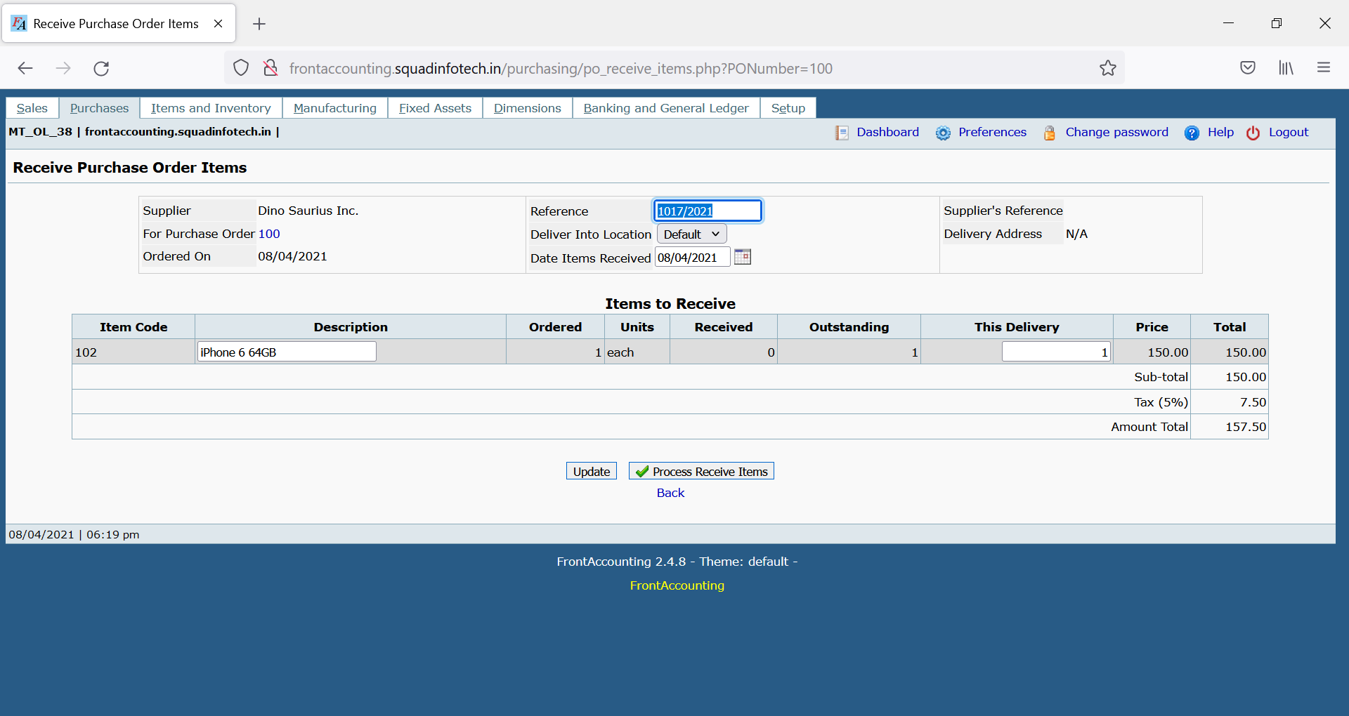

|  |  |
| --- | --- |
| Field | Description |
| Supplier | This field will display name of supplier |
| For Purchase Order | It shows number of PO we had just placed,  If we click on a number, it will open a pop up which contains information about PO. |
| Ordered On | The date when the order was placed. |
| Reference | It should be automatically assigned. |
| Deliver into Location | Name of inventory where PO will be received. |
| Date Items Received | The date when products are received at inventory by the supplier. |
| Supplier’s Reference | It is a non-editable field and it should be fetched automatically from “Purchase Order Entry”. |
| Delivery Address | It is deliver to address entered in PO. |
| Order Comments | It is memo from PO (if entered) |
| Item Code | It is code assigned to selected item |
| Description | It shows name of the selected item |
| Ordered | It shows number of quantities Order |
| Received | It shows number of quantities previously received |
| Outstanding | It shows number of outstanding quantities |
| This Delivery | It will show number of quantities received in this (current) delivery |
| Update | It will update the calculations if there is any change in number of quantities |
| Process Receive Items | It will enter entry of received quantities in database. |

1. **Enter Supplier Invoice : Field Description**

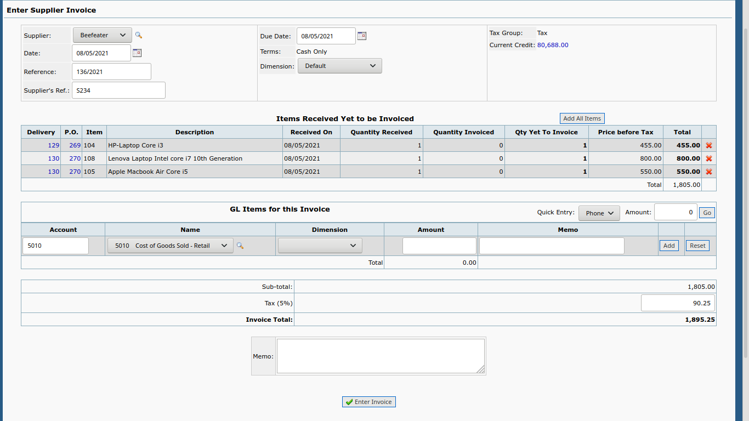

|  |  |
| --- | --- |
| Field | Description |
| Supplier | It will show the name of supplier from whom we are receiving the invoice. |
| Date | Date on which we entering supplier invoices |
| Reference | It is editable field and it should be automatically generated. |
| Supplier reference | It is editable field and it should be fetched automatically from “Purchase Order Entry”. |
| Due Date | Last date till which payment against the invoice should be completed. |
| Quantity Received | This field shows number of quantities received |
| Quantity Invoiced | This field shows number of quantities invoiced. |
| Qty yet to Invoice | It shows number of quantities against which invoice is yet to receive from supplier |
| Add | This button will perform entry of received invoice. |
| Memo | This is optional and User can add comment regarding transaction performed. |
| Enter Invoice | It will entry of received invoices in database. |

|  |  |
| --- | --- |
| Field | Description |
| Supplier | It will show the name of supplier from whom we are receiving the invoice. |
| Date | Date on which we entering supplier invoices |
| Reference | It is editable field and it should be automatically generated. |
| Supplier reference | It is editable field and it should be fetched automatically from “Purchase Order Entry”. |
| Due Date | Last date till which payment against the invoice should be completed. |
| Quantity Received | This field shows number of quantities received |
| Quantity Invoiced | This field shows number of quantities invoiced. |
| Qty yet to Invoice | It shows number of quantities against which invoice is yet to receive from supplier |
| Add | This button will perform entry of received invoice. |
| Memo | This is optional and User can add comment regarding transaction performed. |
| Enter Invoice | It will entry of received invoices in database. |

1. **Supplier Payment Entry: Field Description**

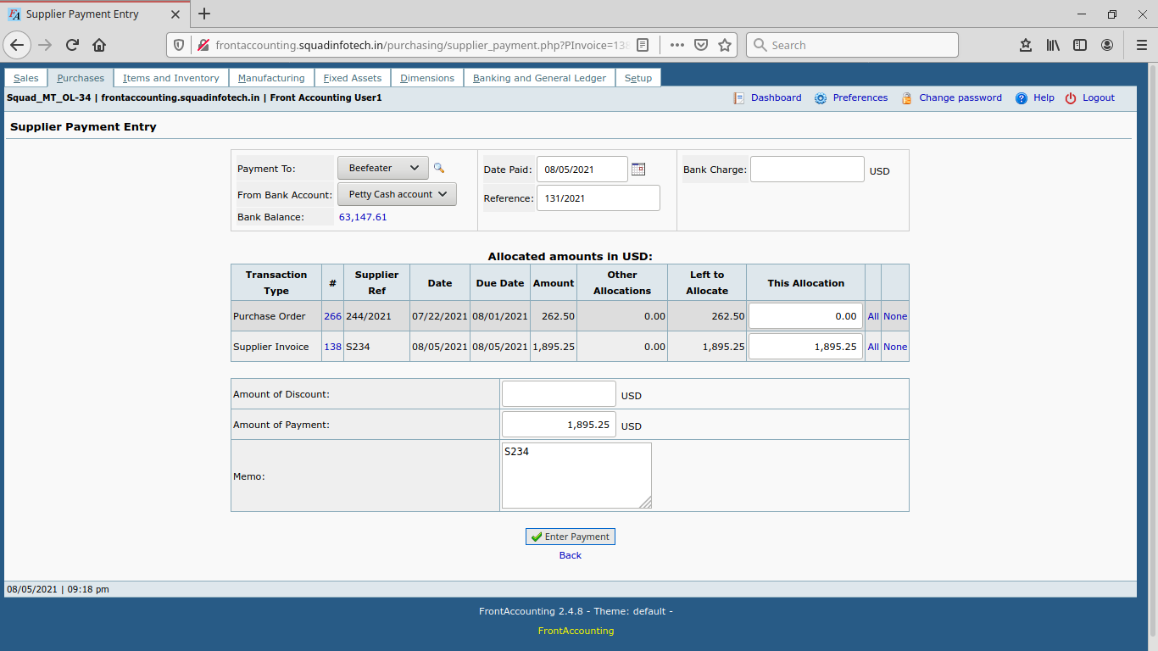

|  |  |
| --- | --- |
| Field Name | Description |
| Payment To | This field display the supplier name to whom we are making payment |
| From Bank Account | This field represents the mode of payment which we are using for making the payment to supplier. |
| Date of Paid | Date of transaction when then payment was done. |
| Reference | This is auto-generated field. |
| Bank Charge | Any charges bank levied on the transaction need to be mentioned here. |
| Transaction Type | This is non editable field. This field must display the type of transaction against which the payment was made. |
| # | The reference of the transaction type number. |
| Supplier Ref | This is non editable field. This field display the supplier ref. number which was mention in supplier invoice. |
| Date | Date when invoice was made. |
| Due Date | Last Date of payment to be made. |
| Amount | Amount as per invoice which was raised. |
| Other Allocations | The amount which was already paid. |
| Left to Allocate | The amount which is pending to be paid. |
| This Allocation | The amount which we are going to paid in this current transaction. |
| All | This link will take all the amount as per invoice which was raised. |
| None | This link should reset the “This Allocation” amount. |
| Amount of Discount | If the Supplier gave discount, mention the amount in this field. The amount should not be same as “This Allocation”. |
| Amount of Payment | This field should display the final amount after deduction of the discount amount. |
| Memo | This field should display the information mentioned in Comments field while entering the Supplier Invoice. |
| Enter Payment | This button should make a successful Payment Entry to the supplier. |

1. **Inventory Location Transfers: Field Description**

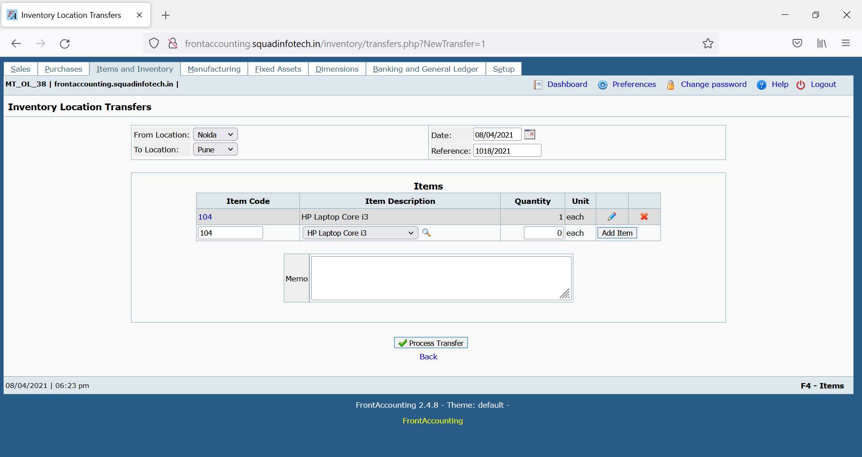

|  |  |
| --- | --- |
| Field Name | Description |
| From Location | Drop-down list of different warehouses. User can select the warehouse from which the product should get transfer. |
| To Location | Drop-down list of different warehouses. User can select the warehouse in which the product should get transferred. |
| Date | Default value is system date when the product is getting transfer. This field may permit past date but should not permit future date. |
| Reference | This is auto-generated field. |
| Item Code | This field should allow the user to directly type the item code of the product for which the transfer is getting done. |
| Item Description | This is alternate way to add item in the list for transfer product. Instead of adding item using Item Code, user can select the product from the drop down. |
| Quantity | Default value should be 1 quantity. |
| Add Item Button | This button should add the item in the location transfer. On successful entry of the product, Edit button (displayed as Pencil icon) and Delete button (displayed as Red X) should be displayed. |
| Memo | This field should allow the user to mention the information regarding the transfer is being made. |
| Process Transfer | This button should make a successful Transfer of products as per the locations. |

1. **Inventory item movement report :Field Description**

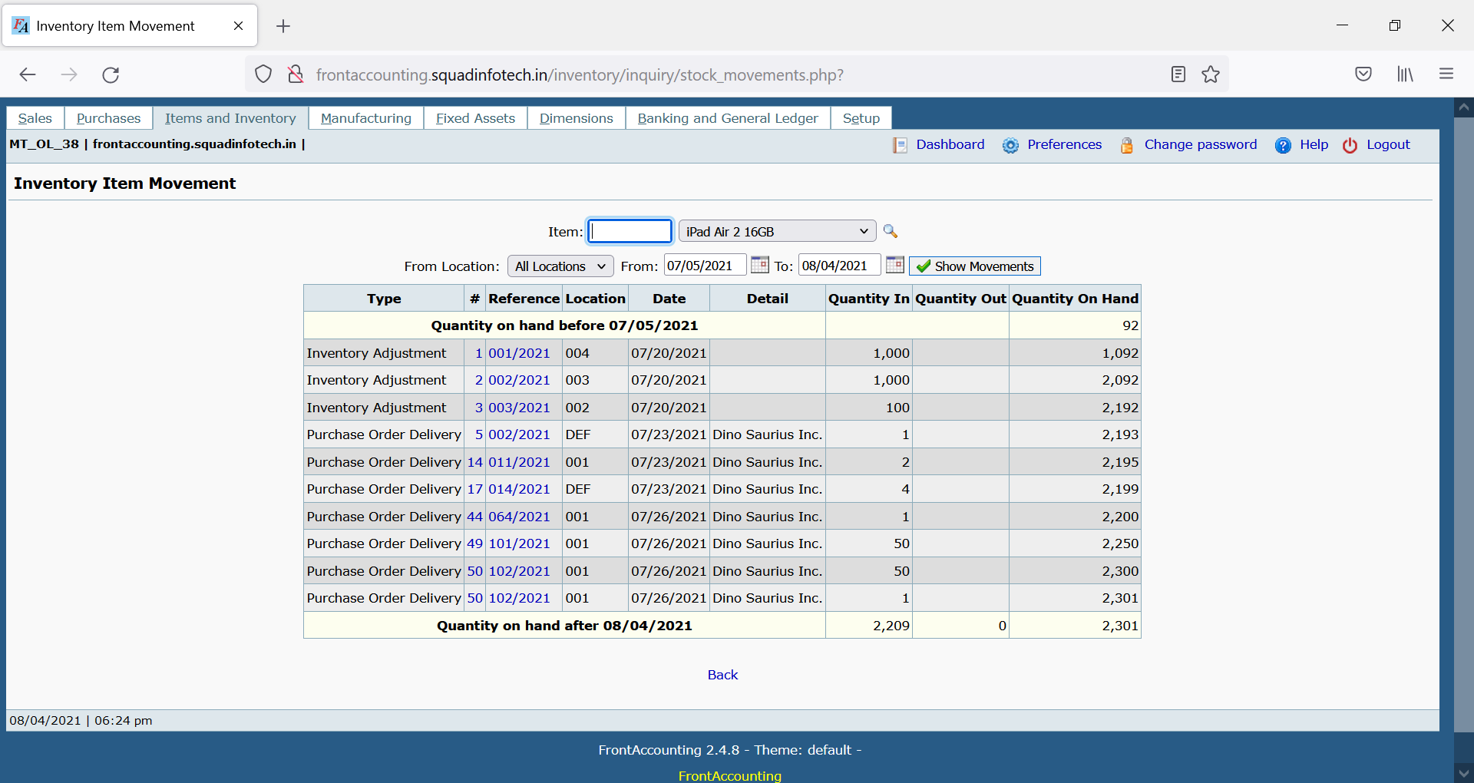

This report shows Movement of particular item, at selected location , in selected date range in terms of Quantity In, Quantity out and Quantity on Hand

|  |  |
| --- | --- |
| Field Name | Description |
| Item | Item can be selected by entering item code or selecting item name from drop down |
| From location | location at which we want to find movement of the item can be selected |
| From---to | Date range can be selected |
| Show movement | Generates required Inventory item movement report |
| Quantity in | Quantity of the item **added in to the stock** of the location,  due to purchase activity or inventory location transfer activity |
| Quantity out | Quantity of the item dispatched from the location due to sales activity or inventory location transfer activity |
| Quantity on hand | Total quantity of the item in the stock of the location/branch |

1. **Inventory item Status report : Field Description**

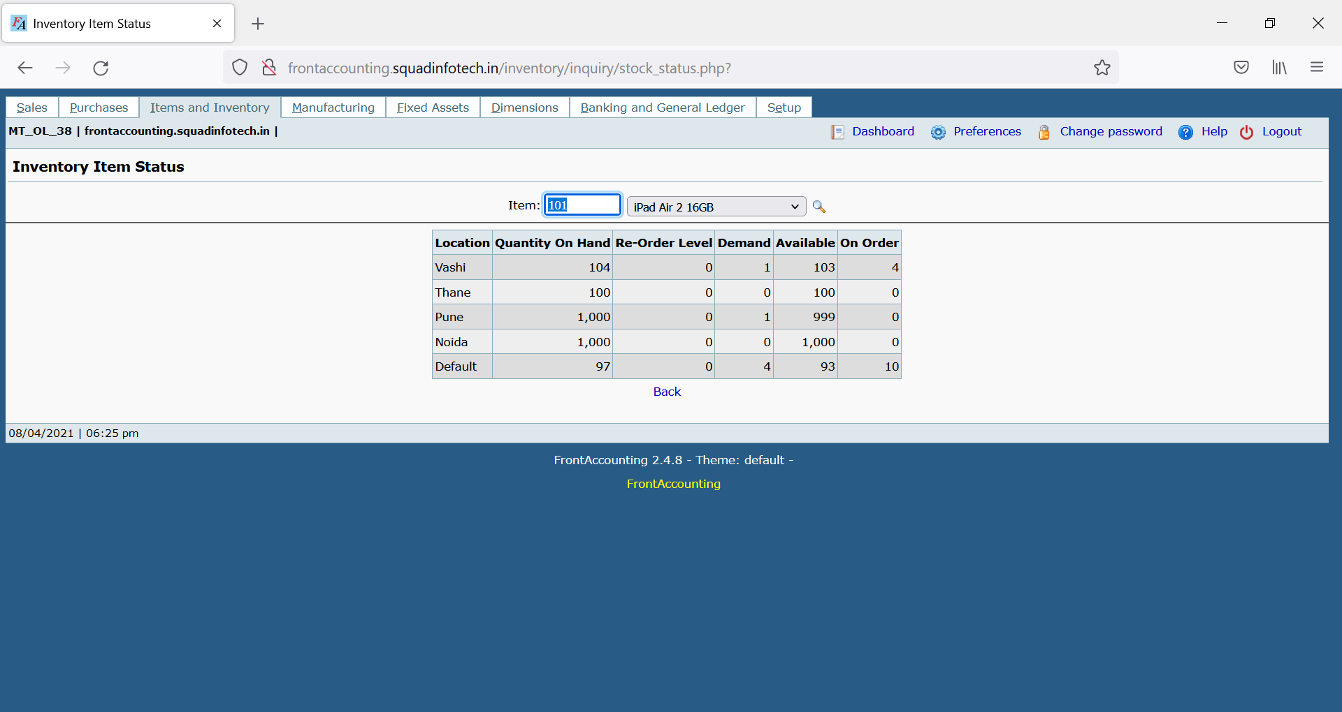

This report shows Status of particular item, at all location in terms of Quantity on Hand, Reorder level , Demand, Available and on order

|  |  |
| --- | --- |
| Field Name | Description |
| Item | Item can be selected by entering item code or selecting item name from drop down |
| Quantity on Hand | Total quantity of the item in the stock of the location/branch |
| Re-Order Level | Feature not to be tested) |
| Demand | Demand is the quantity of item for which sales order is created but not yet delivered. |
| Available | Actual quantity of the item available for sale  (demand=Quantity on hand -demand) |
| On order | Total quantity of items for which purchase order is created but not yet received. |